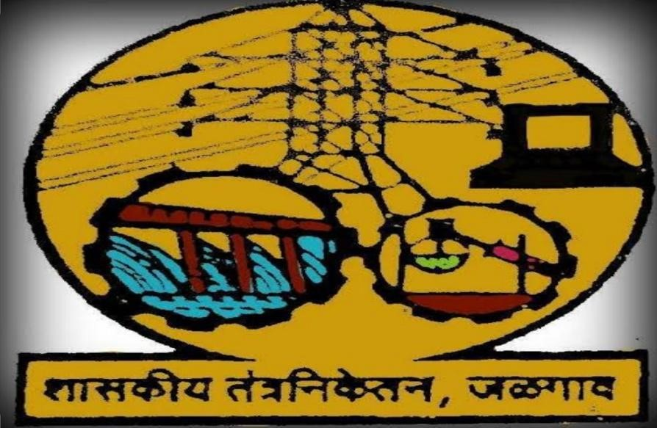

Government Polytechnic Jalgaon

Academic Year (2020-21)

Entrepreneurship Development

(22032)

EJ6I



**MAHARASHTRA STATE BOARD OF**

**TECHNICAL EDUCATION**

# Certificate

This is to certify that Master Mr/Ms. **Prathamesh, Mandar, Mohish, Mohit** Roll No.**11, 23, 24, 25** Of **6th** Semester of Diploma in **E&TC.** Of Institute, **Government Polytechnic, Jalgaon (Code:0018/1567)** has completed the **Micro Project** satisfactorily in the **Subject** Entrepreneurship Development (22032) for the Academic Year 2020- 2021 as prescribed in the curriculum.

Place**: Jalgaon** Enrollment No:-

**1800180265,1800180288,1800180290,1800180291**

Date:-

Exam. Seat No:-

## Subject Teacher Head of the Department

**TITLE**

**To study and prepare a detail report on general**

**organizational structure of electronics based industry**

**Submitted by-:**

1. Prathamesh Saraf (11)
2. Mohit Bhangale (23)
3. Mandar Patil (24)
4. Mohish Khadse (25)

**Under the guidance of:**

**Prof. K.P Akole**

**Index**

|  |  |  |  |  |
| --- | --- | --- | --- | --- |
| **Sr no** | **Topic** | **Page no** | | |
| **1** | **Rational** | **6** | | |
| **2** | **Introduction** | **7** | | |
| **3** | **General organizational structure for any electronics based the industry**   * Functional Organization * Product Division * Regional division | **8** | | |
| **4** | **Key segments of electronics industry**   * Semiconductor supply and manufacturing * Industrial Equipment * Networking and Communication Equipment * Computer and Office Products: * Medical Devices * Consumer electronics and home appliances | **9** | | |
| **5** | **Electronics Industry Value Chain**   * Product and Service Development * Procurement, Supply, and Manufacturing: * Marketing, Sales, and Service | **`10** | | |
| **6** | **Key Terms in the Electronics Industry**   * Cost of Goods Sold (COGS) * Days Sales Outstanding (DSO) * First Pass Yield | **11** | | |
| **7** | **Competitive Advantages in Electronics Industry**   * Advancements in Technology * Globalization * Information |  | | |
| **8** | **Functions in the Electronics Industry**   * Product Development and Engineering: * Manufacturing: * Supply Chain and Operations * Sales * Marketing * Customer Service * Finance and Accounting * Human * Information Technology | | **12** |
| **9** | **Referances** | | **13** |

## 1. Rational

Globalisation liberalization and privatization along with revolution in information technology have open up new opportunities transforming lives of masses in this context there is a immense opportunity of establishing manufacturing, service , trading , marketing and consultancy enterprises by diploma engineers owe fast growing economy provides ample scope for diploma engineers to succeed as an entrepreneur. Entrepreneurship requires distinct skill set which are attempted to be developed through the course to begin with this course aims to develop the competency and the related outcomes in order to start small enterprises

## 2. Aims and Benefits of Micro Project

* The aim of the project is to understand the organizational and administrative structure of the electronic based industry
* It will help us to know how the electronic based industry is organized and runs its administration smoothly
* It will help us to develop comprehensive plans to run the electronic industry effectively

## 3. Course outcomes (COs)

* Identify your entrepreneurial traits
* Identify the business opportunities that suits you
* Prepare plans to manage the enterprise effectively

## Introduction

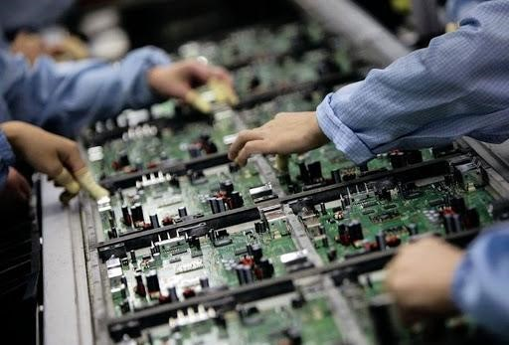The Electronics Industry is made up of companies that manufacture, design, manufacture, assemble, and service electronic products. These products consist of materials, parts, components, subassemblies, and equipment that use the principles of electronics to perform their major functions. Products can range from discrete components like integrated circuits; consumer electronics like TVs, smartphones, andpersonal computers; medical equipment like heart-rate monitors and dialysis machines; industrial equipment like robots; to communication and networking equipment like routers and switchboards.

Industries that are supported by the electronics industry include automotive, aviation, defense, telecommunications, entertainment, and healthcare. The Electronics Industry is driven by innovation and a lot of money and effort goes into research and development to design and make improved parts and products, as well as improve manufacturing processes. Companies in the electronics industry are always in tough competition to implement innovative ideas and introduce the newest technology in the market first. This puts a lot of pressure on design and engineering teams to develop and create innovative products and services faster and cheaper. Sales and marketing teams are also under pressure to drive sales and ensure that profit margins remain way above production and operational costs. Many electronic companies are also experimenting with and utilizing advanced analytics to provide insights that can help improve processes and bring in more profits. Companies are also specializing in specific niches to guarantee sustainability and maintain profitability. Many electronics manufacturing companies are outsourcing manufacturing and production of parts or products. The rise of Electronics Manufacturing Services (EMS) and Contract Electronics Manufacturing (CEM) companies is a testament to that. These are companies that are contracted to manufacture parts or products for other companies, and also provide a variety of value-added services. This allows the contracting companies to concentrate their efforts on other strategies that will help drive sales and help them remain competitive on the global market

|  |  |
| --- | --- |
| **General organizational structure for any electronics based the industry**  there should be three types of the division  **Functional Organization** | |
| This type of industrial organizational structure divides a staff into departments by duties. A director or vice president in charge of each function reports directly to the CEO or president. Functions include manufacturing, engineering, marketing and finance. Each department handles functions such as human resources if a separate department for such does not exist. Managers take charge of | *Figure 2* |
| the divisions under functions such as budgeting and accounting under finance, and sales and advertising under marketing.  **Product Division**  Companies that produce or market a large variety of products use business organization structures that divide key positions to manage each product group. The CEO of an electronics firm, for instance, assigns a director to each product division such as cellphones, TVs and monitors. Each division has a similar structure with a manager in charge of production , marketing and engineering. Department stores use product divisions with a manager in charge of each department.  **Regional Divisions** | |

Some large scale companies which has its global markets and has reach in other countries follows the regional divisions structures for instance take a example of the Samsung industry Samsung uses geographical groupings or divisions as a minor characteristic of its corporate structure. In the company’s organizational chart, these geographical divisions are generally under the product-type divisions. For example, Samsung Electronics North America is a geographical division within Samsung Electronics, which is a product-type division. Through this characteristic of the organizational structure, the company implements region-specific strategies, such as strategies intended for the North American market for Device Solutions.

### Key Segments of Electronics Industry

* **Semiconductor supply and manufacturing services:** This segment does design and manufacture work, and supplies everything related to semiconductors including electrical components and integrated circuits that are common in many electrical and electronic devices. It supports almost every industry you can think of including medical, aviation, automotive, telecoms, etc.
* **Industrial Equipment:** This segment manufactures equipment that assists in industrial processes. Equipment can range from industrial robots, automation and control systems, wafer-processing equipment, semiconductor assembly and packaging equipment, electronic testing and measurement equipment, etc.
* **Networking and Communication Equipment:** This segment comprises manufacturers of consumer and industrial networking hardware and other communication equipment. This could be routers, LANs, WANs, switchboards, bridges, hubs, and gateways. Examples of companies specializing in this segment include Cisco Systems, Extreme Networks, Telco Systems, etc.
* **Computer and Office Products:** These are producers of a wide range of business-related electronic equipment like copiers and fax machines, and computing equipment including personal computers, servers, mainframes, and workstations.
* **Medical Devices:** This segment deals with the manufacture of electro-medical equipment used in diagnosis, surgical procedures, medical imaging, forensics, and medical research and training. Such machines include ultrasound devices, X-ray machines, dialysis machines, heart-rate monitors, and so on.
* **Consumer electronics and home appliances:** This is a major segment in the electronic industry and produces consumer products such as Televisions, radios, DVD players, video gaming systems, mobile phones, cameras, electronic ovens, etc. They also produce home intercommunication and alarm systems.

**Electronics Industry Value Chain?**

* **Product and Service Development:** This stage encompasses all the steps involved in transforming an idea into a final product or service. Normally, a product is taken through design, analysis, testing, and modification before it can go into production. The product will also have to meet specific consumer requirements and demonstrate that it has a worthy ROI.
* **Procurement, Supply, and Manufacturing:** Sourcing and supply of necessary raw materials and components needed for manufacturing a product or for delivering a service. This stage makes use of inventory management, quality analysis and control, and production line optimization to ensure there is both efficiency and a smooth flow of production operations.
* **Marketing, Sales, and Service:** Marketing is all about helping the business to drive sales for its products and services through such means as advertisements, promotions, etc. Marketing teams also provide feedback to product development and manufacturing teams, which can be used to make improvements based on consumer preferences and market needs. At this stage, businesses receive and process orders, and then deliver products and services to customers. This may be followed by after-sales services lik commissioning, maintenance, repair or any other support services.

**Key Terms in the Electronics Industry?**

Basic financial and quality measurements include

* **Cost of Goods Sold (COGS):**The sum cost of materials, manufacturing, labor, and profit for the product you’re selling. This also includes costs incurred when transporting and delivering the product to consumers.
* **Days Sales Outstanding (DSO):** The average number of days that it takes a company to collect revenue from its credit sales or when a company's account receivables can be collected.
* **First Pass Yield**: The percentage of the total number of goods produced successfully in comparison to the number of units going into the process over a specified period of time.

Key terms within the semiconductor segment include:

* **Book-to-bill ratio:** The ratio of orders received over a specific period to the number of orders billed during the same period.
* **Fabless:** Refers to a semiconductor company that outsources its wafer manufacturing operations to a chip foundry.
* **Foundry:** A semiconductor fabrication plant/company that is usually contracted by other companies to makes chips or silicon wafers for them.

### Competitive Advantages in Electronics Industry

Electronics is one of the rapidly evolving and highly innovative industries, where competition is tough and rigorous. Here are a few competitive advantages that can determine whether a company will remain competitive in the electronics industry.

* **Advancements in Technology:** Technology has been and will continue to be a determining factor on how sustainable and profitable a company in the electronics industry will be. Companies will have to invest more in R&D, restructure, and become more service-oriented by leveraging such technological advancements as the Internet of Things (IoT). Electronic equipment manufacturers will have to make use of robotics and automation to improve both efficiency and productivity. Some companies have already integrated different sensor technologies in their manufacturing processes to gather substantial data that can provide timely insights to drive growth and profits.
* **Globalization:** The internet is giving companies in the electronics industry a low-cost channel for retail distribution. Products can now be shipped to customers in any place in the world and reach them within a day or two. This has empowered companies would otherwise have been considered minnows to stamp their presence on global markets. Companies are now competing on matters price and efficiency on a global level. They are also penetrating larger and larger geographical markets riding on internet capabilities. When this is coupled with low production costs, the result is the emergence of such countries as China and India as influential forces in software design and development.
* **Information:** Information is proving to be a competitive advantage in the fastpaced electronics industry. Obtaining, processing, and transmitting information is becoming less costly. By leveraging acquired knowledge, companies can rethink and perform comprehensive analysis of their product development, design and sales strategies. For instance, companies can follow trends in the industry and use consumer feedback to design innovative products or deliver services that satisfy consumer needs. On the other hand, consumers have become more aware of products and their prices, and so have an apparent bargaining position on electronic vendors. Companies will, therefore, need to introduce such strategies as product differentiation to counter and cash in on this consumer empowerment.

### Functions in the Electronics Industry

* **Product Development and Engineering:** This involves conceptualizing an idea to design a product. Product development and engineering teams are expected to design, make prototypes, perform quality and performance tests, and finally roll out the product or service. They make improvements on products using feedback from marketing teams and working closely with R&D. They also design innovative tools and techniques to make products in a fast, less-costly process.
* **Manufacturing:** The manufacturing department is expected to transform a product design into a real workable product. This department works in collaboration with design teams to explore how best they can improve production lines to make products faster and with reduced operational costs. They also work together with the supply chain team to improve efficiency in the manufacturing process.
* **Supply Chain and Operations:** This department is tasked with the procurement and storage raw materials, and distribution of final products to consumers. The supply chain needs to be efficient in order improve productivity and ensure that goods reach customers on time. To do this they work in partnership with manufacturing teams to process orders, with sales channels to manage inventory, and with transportation providers to plan on the delivery of products.
* **Sales:** The sales department is tasked with generating revenue for the business through the sale of products. They are supposed to work with marketing teams to create plans and strategies that can help in penetrating new markets, maintaining existing markets, and boosting sales performance. Since they are in direct contact with existing customers, they are expected to provide feedback to the management and design and manufacturing teams on ways they can add value to the existing products.
* **Marketing:** Marketing involves promoting and creating a good image for the company’s products so as to grow the company’s market share and profit**.** This is done through various channels including TV, billboards, social media platforms, customer loyalty programs, and promotional campaigns directed at target markets. The department also performs market research and partners with sales to develop market plans and improve sales performance.
* **Customer Service:** Their main job is to communicate directly with customers, answer their questions, process their requests and resolve their complaints. This can be done one-on-one, over the phone or through online chats. They should then provide feedback and insights to relevant departments.
* **Finance and Accounting:** This department is tasked with all financial operations of the company. This includes financing projects and operations, maintaining accounting records, creating financial and budget controls, preparing financial statements, and Managing credit and cash.
* **Human Resources:** Human resources team deals with matters related to employees including recruitment, compensation, and benefits. They also help the company to sort out its legal obligations like licenses, permits, tax compliance, etc.
* **Information Technology:** The IT department is responsible for planning, establishing, and maintaining networking, communication, and office-related infrastructure and equipment. They are also expected to leverage new technologies to improve products and processes or help design new processes that can help expand markets and increase profits.

**Referances**

1. <https://www.sciencedirect.com/topics/computer-science/electronics-industry>
2. <https://www.predictiveanalyticstoday.com/what-is-electronics-industry/>
3. <https://www.investindia.gov.in/sector/electronic-systems>
4. <http://panmore.com/samsung-corporate-organizational-structure-characteristics-analysis>